**PROJECT PLAN**

Blue Team

Clothing Store Website

1. **Introduction:**

This project will introduce a web-based shopping system. The main purpose of the project is to build a platform where buyers and sellers can connect online. Registered users can use the ID and password to log into the website. All users can view various products, and they can add products to their shopping cart to process checkout. This project is an attempt to provide the advantages of online shopping to customers of a real shop. It helps buy the products in the shop anywhere through the internet by accessing the website.

1. **Project Organization:**

| ***Position*** | ***Team Member*** | ***Job Description*** |
| --- | --- | --- |
| *Team Leader* | Alysha Marin | Ensures the group stays on track to finish our respective tasks by the deadline. Keeps track of important materials and documents. |
| *Designer* | Dylan Moreland | Creates software design and keeps it simple to follow and implement. |
| *Programmer* | Christopher Scholl | Writes the code to the software design's specifications. |
| Trang Huffman |
| *Tester* | Alexander Cline | Tests the program for issues and bugs. |

1. **Risk Analysis:**

**The cost risks:**

**Potential risk Cost**

UX/UI Design $750 - $4000

Front-End Development $1000 - $12,500

Back-End Development $4,000 - $12,000

Content Management Sys. $3,000 - $9,000

The UX/UI cost will vary on the size of the project. As does most of these costs. With the front-end, back-end, and UX/UI, the sophistication and elegance of the operation will cost more the more detail is put into it. All these costs will be on the high side if you use an experienced programmer to meet your needs. These are the major development costs. There are other ones like these:

Domain Name $5 - $15 a year

Actual Design $2000 - $15,000

Optimize Performance $3,000 - $25,000

Website Hosting $75 - $200 a year

Update CMS $500 - $12,000

Cyber Security $10 - $1,000 a month

Marketing $4,000 - $20,000

**The schedule risks:**

UX/UI Design 1-2 weeks

Front-End Development 2-6 weeks

Back-End Development 3-8 weeks

Content Management Sys. 3-8 weeks

Any of these areas can fall behind in scheduling. A programmer could miss work or there could be a system failure. Issues could arise from the design of the website. The site we choose to host could falter and go down. We could have copyright infringement on clothing that we would need to get fixed which would add to the cost of the project. Debugging could take longer than expected. A member could not get their part and the work would have to be picked up by others.

**Performance Risks:**

Speed. The obvious most important would be the user’s experience, and a slow website will not have them coming back to shop again.

Scripts not working. We could not get the right scripts coded for forms and such to get back the right data we intended to get. They could also be running taking up valuable running operations from other areas that need it.

Low search rankings. The website could be hard to find and not show up on Google or any other search engine's first page or even the first couple of pages. Getting a higher ranking by having a fast, good, clean, and lean website will help your rankings. Can pay to be put higher.

The database could not update properly and say we have available items that are not available anymore.

**Operational Risk**

| **Risk:** | **Probability:** | **Effects:** |
| --- | --- | --- |
| Inadequate resource allocation. This could include spending too little time or too much time on certain aspects of our project. | Moderate | The chance that inadequate allocation of resources occur will be serious. It could delay the release of the product and push back milestones that need to be met. It can also decrease productivity. |

*Risk Planning:* To approach operation risks that may occur in the span of building our project, we will implement minimization strategies.

1. To avoid our resources being allocated inefficiently, we will develop a concise project plan. This will set a timeline and where our resources will be used when and how much.
2. We will set milestones and objectives. This will help prioritize important tasks that need to be done.

**Technology Risk**

| **Risk:** | **Probability:** | **Effects:** |
| --- | --- | --- |
| Data is lost or corrupted due to hardware malfunctions, system failures, or poor backup mechanisms. | High | The event of data loss will be catastrophic. This will threaten the possibility that the project will be completed in time. |
| Compatibility issues due to different programming languages, frameworks, and devices being used for the project. | Low | The event of compatibility issues will be tolerable, but it could consume more resources and time being wasted. |

*Risk Planning*: Our plan to address any technology risks that may occur in the span of building our web application is to use avoidance strategies.

1. To avoid data loss, we will ensure to have multiple backups of our project stored in different locations.
2. To avoid compatibility issues, we have established the standardized technology that will be used for the project.

**Communication Risks**

| **Risk:** | **Probability:** | **Effects:** |
| --- | --- | --- |
| Messages being misunderstood or misinterpreted. | High | Poor communication can lead to misunderstandings,  And not clear about roles and responsibilities. |
| Team members missed weekly group meetings, not join the group chat (Discord). | High | Not being able to catch up with the workload, and delays in providing regular updates on progress |

**Planning:** Team members will ensure that everyone is on the same page about expectations and goals, and provide feedback and input throughout the project. In every meeting, we will include details such as who will be responsible for which parts, and when updates will be provided, and what type of information will be shared.

**Scope Creep Risk**

| **Risk:** | **Probability:** | **Effect:** |
| --- | --- | --- |
| The team member requests modifications in the project somewhere in the middle of the process | Low | This team will spend extra time going back to the drawing board and reworking things. This will delay work and deadlines to be missed, which can affect the success of the project. |
| adds additional work to the project’s scope, and has to juggle prior commitments | Low | Adding new features that will not be accounted for in initial estimates for the project. This will raise the cost and lower the project probability due to the additional and unaccounted staffing hours. |

**Planning**: Listing every task that needs to be completed to complete the project. Setting the estimated time for each task, the estimated cost for each task, and the total cost of the project.

**Skill Resource Risk**

| **Risk:** | **Probability:** | **Effect:** |
| --- | --- | --- |
| The team might not have enough resources to meet the project’s needs. The resources may include time, skill, money, or tools | Low | This can delay project timelines, increase costs, and lower the quality of project results. |

**Planning:** We will create a resource allocation plan, which makes the best use of team resources while maximizing resource impact and supporting team goals. When we know what resources we need from the beginning, we minimize the chance of running out of resources later.

**4**. **Hardware and software requirements:**

Hardware Requirement:

* Computer
* Computer Server
* Keyboard and mouse

Software Requirement:

* Programing language Python
* Github
* Discord
* PythonAnywhere

**5. Work breakdown:**

| **Work Breakdown** | |
| --- | --- |
| Task #: | Task: |
| **1.1** | **Phase 1: Research/Planning** |
| 1.1.2 | Requirements Document |
| 1.1.3 | Feasibility Document |
| 1.1.4 | Risk Planning Document |
| 1.1.5 | Project Plan |
| **1.2** | **Phase 2: Design** |
| 1.2.1 | Flow Charts / Diagrams |
| 1.2.2 | Use Cases |
| 1.2.3 | Test Cases |
| 1.2.4 | Design Document |
| **1.3** | **Phase 3: Implementation** |
| 1.3.1 | Set up server environment |
| 1.3.2 | Develop backend functionality |
| 1.3.3 | Develop the UI design |
| 1.3.4 | Code HTML/ CSS for website frontend |
| 1.3.5 | Implementation Plan Document |
| **1.4** | **Phase 4: Testing** |
| 1.4.1 | Test individual components for functionality |
| 1.4.2 | Check for bugs or errors |
| **1.5** | **Phase 5: Deploy** |

**6. Process Flow Diagrams:**

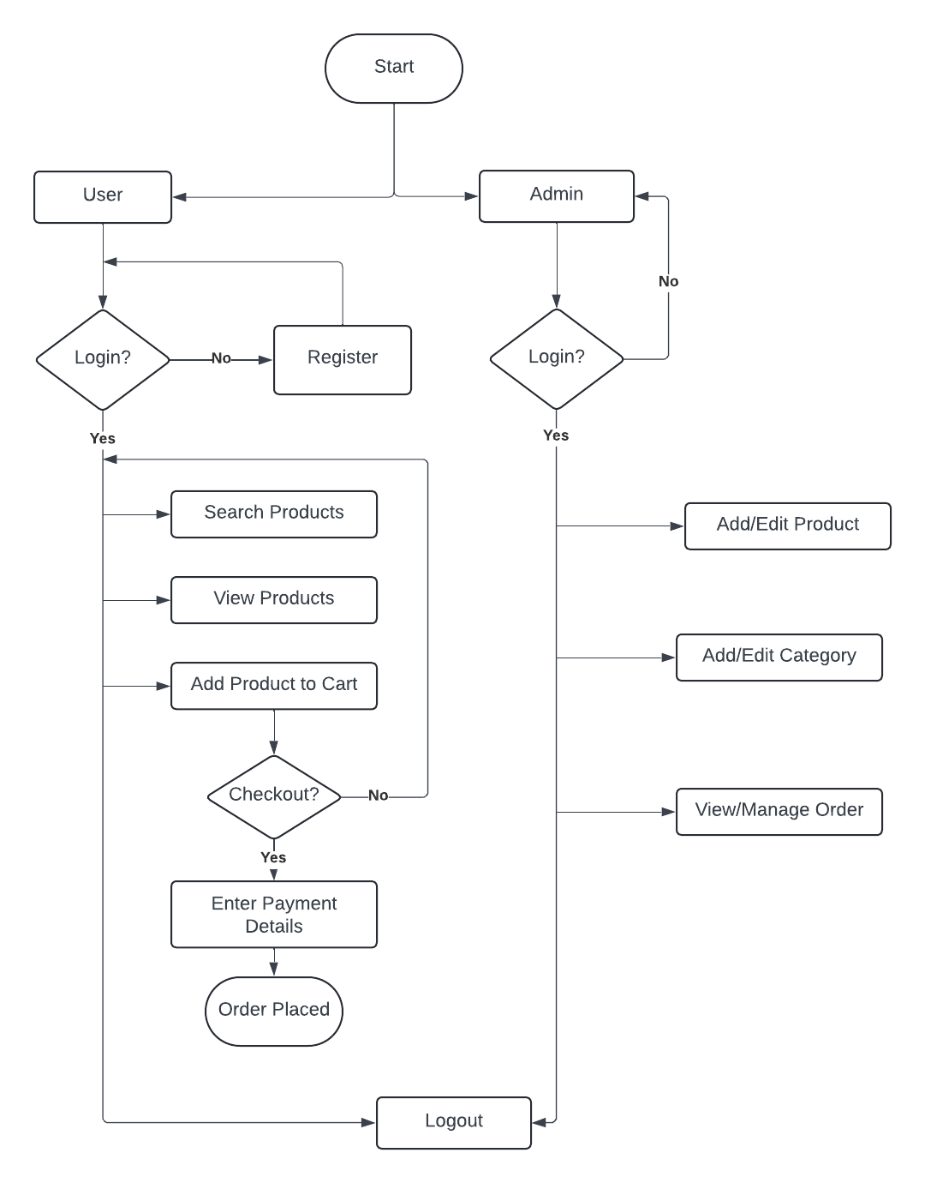

**7, Project Schedule:**

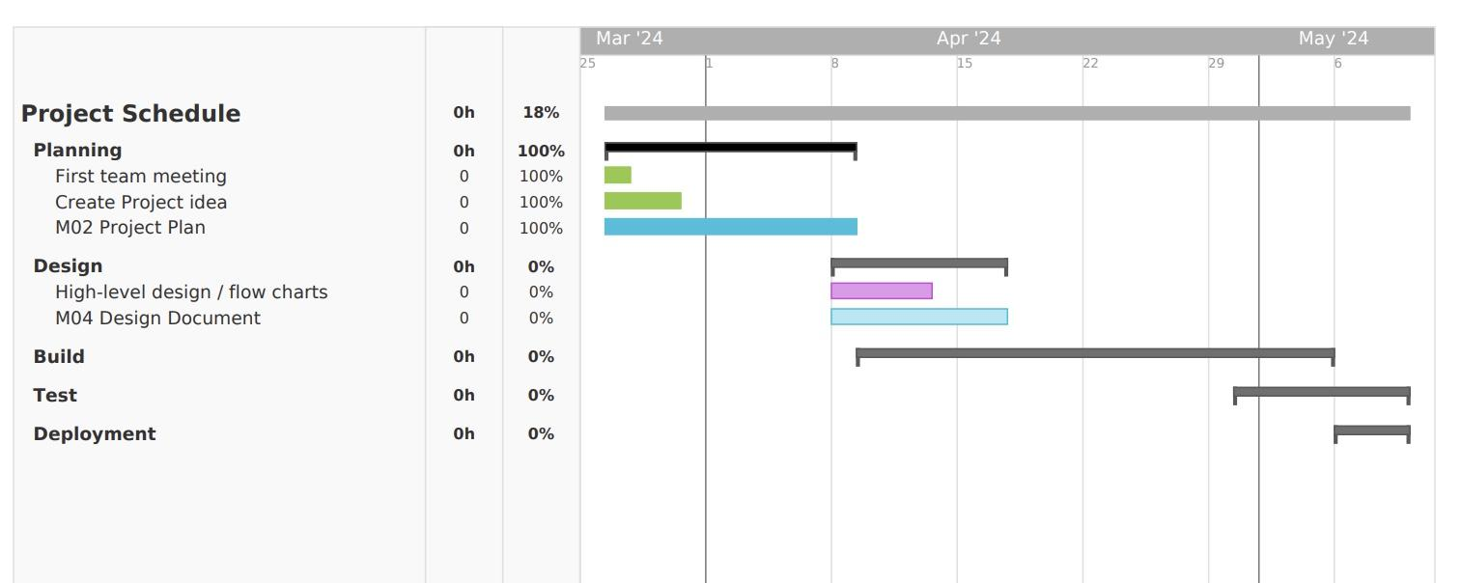

**8. Monitoring and reporting mechanisms:**

We will be using Discord as our primary form of communication and using Discord’s voice channel for our meetings where we can share our screens. We are all uploading our assignments and research into the Google Drive that was set up for the Blue Team. We use the class Zoom meetings as our team meetings and we meet Mondays on Discord before the assignments are due to put all the collaborated work together. We use a Trello board for work to be done and what is done. We have a GitHub repository set up and will be using VS Code, Replit, and Python Anywhere during the lifespan of this web application project.We will be using the Python language with Django, and Flask, and using HTML and CSS for the web pages.

**9. Appendix:**

| **Task Number** | **Task Description** | **Duration (weeks)** | **Dependencies** |
| --- | --- | --- | --- |
| **101** | **Planning** | **1** |  |
| **102** | **Design** | **2** | **101** |
| **103** | **Build:**  **Inventory pics** | **2-4** | **101-102** |
| **104** | **Build:**  **Framework** | **2-4** | **103** |
| **105** | **Build:**  **Home/Login pages** | **2-4** | **103-104** |
| **106** | **Build:**  **Clothing pages-3 or 4** | **2-4** | **103-105** |
| **107** | **Build:**  **Favorites page/Cart** | **2-4** | **103-106** |
| **108** | **Build:**  **Membership** | **2-4** | **103-107** |
| **109** | **Build:**  **Debugging/Troubleshooting** | **4** | **103-108** |
| **110** | **Testing** | **3** | **103-109** |
| **111** | **Deployment** | **1** | **103-110** |
| **112** | **Maintenance** | **-** | **111** |